Grade 7 Accelerated · Unit 4  Unit 4 Review  Solving Problems with Rational Numbers ANSWER KEY | Name  Date  Period

Show your work. Circle your final answer.
HOW TO USE THIS. This review covers every learning target from the unit — more than the assessment does. Work it in parts. If you miss two or more in a part, that part is where to spend your study time. The reference sheet has everything you need for each part.
PART A. Adding and Subtracting in Scientific Notation Lesson 1 · MA.8.NSO.1.5 · 6 questions
1. 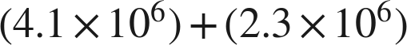
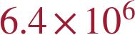
Same power: add the coefficients, copy the power down.

2.
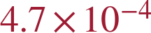

3. 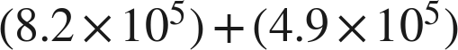

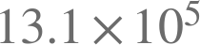 is the value and not the finished form.

4. 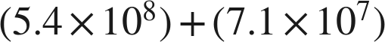

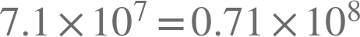.

5.
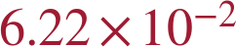
; the exponents are two apart, the widest gap allowed.

6. Lena writes . Name her two mistakes and give the correct sum.
She added the coefficients without first writing both over the same power of ten, and she added the exponents. The sum is 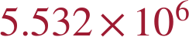.
, and .

PART B. Multiplying and Dividing in Scientific Notation Lessons 2–3 · MA.8.NSO.1.5 · 6 questions
7. 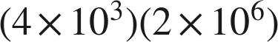

Multiply the coefficients, add the exponents.

8. 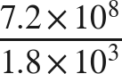

Divide the coefficients, subtract the exponents, top minus bottom.

9. 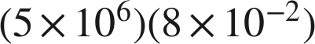
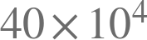 is not finished.

10. 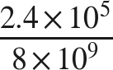
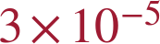
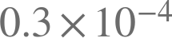 is not finished either.

11. 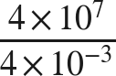

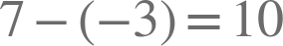. Subtracting a negative goes up.

12. A laser emits 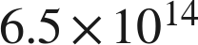 photons each second. How many does it emit in 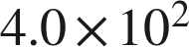 seconds?
 photons
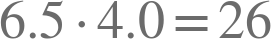, so 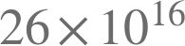 before it is finished.

PART C. Real-World Problems and Significant Digits Lesson 4 · MA.8.NSO.1.6 · 6 questions
13. How many significant digits are in each measurement? 6,040 g · 0.00920 m · 45.00 s
3 · 3 · 4
6,040: the middle zero counts, the trailing one does not. 0.00920: leading zeros never count, the trailing one does. 45.00: all four.

14. A rectangular panel measures 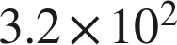 mm by 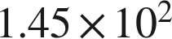 mm. Find its area, with the correct number of significant digits.
 square millimeters
46,400 exactly; 2 significant digits and 3, so the answer keeps 2.

15. A train travels 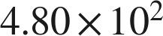 km in 6.0 hours. Find its average speed, with the correct number of significant digits.
 km/h
Exactly 80; two significant digits are justified, so it is written 80 with both digits.

16. Two lengths are measured: 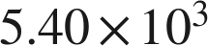 mm and 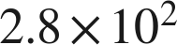 mm. Find their sum, with the correct precision.
 mm
5,400 and 280 both stop at the tens place, so the sum, 5,680, does too.

17. Two masses are measured: 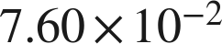 g and 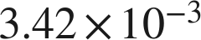 g. Find their difference, with the correct precision.
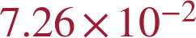 g
0.07258 exactly; 0.0760 stops at the ten-thousandths, so the answer stops there and rounds up.

18. Micah adds two measured lengths, 2,340 m and 6.8 m, and says the sum must be written with two significant digits, as 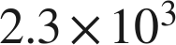 m. Is he right? Explain, and give the correct sum.
He is not right. The counting rule is for products and quotients; a sum stops at the leftmost last-digit place. 2,340 stops at the tens and 6.8 at the tenths, so the sum, 2,346.8, stops at the tens: 2,350 m, or 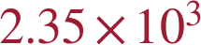 m.
The trailing zero of 2,340 is not significant, so its last significant digit is the 4, in the tens place.

PART D. Evaluating Expressions with Radicals Lesson 5 · MA.8.NSO.1.7 · 7 questions
19. 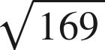
13

20. 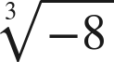
−2
An odd root keeps the sign of its radicand.

21. 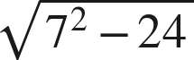
5
Finish under the bar: 49 − 24 = 25.

22. 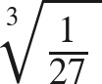
Top and bottom each get the root.

23. 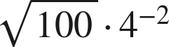
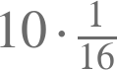.

24. 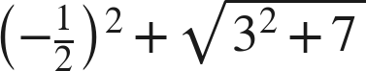

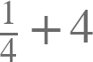.

25. Kai says that 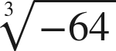 is not a real number. Is he right? Explain.
No. A cube root asks for the number used three times, and , so the value is −4. It is a square root of a negative number that is not a real number.
This is the first misconception the state guide names for this benchmark.

PART E. The Order of Operations Lesson 6 · MA.8.NSO.1.7 · 7 questions
26. 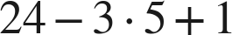
10
Multiply first, then left to right.

27. 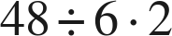
16
One level, left to right: 8 · 2. Not 4.

28. 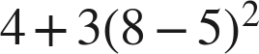
31
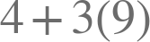.

29. 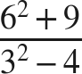
9
45 over 5.

30. 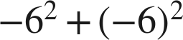
0
The exponent attaches to its own base; the parentheses decide what that base is.

31. 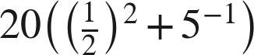
9
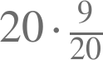.

32. Which expression is equivalent in value to 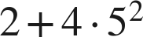 ?
○ A. 
● B. 
○ C. 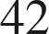
○ D. 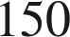
B

PART F. Real-World Problems and the Order of Operations Lessons 7–8 · MA.8.NSO.1.7 · 5 questions
33. Evaluate 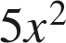 when 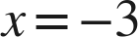.
45
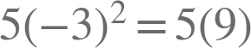.

34. Kinetic energy is . Find  when  kg and 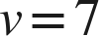 m/s.
9,800 joules
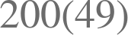. The unit is part of the answer.

35. A gym charges 30 dollars to join plus 12 dollars for each of 4 months. A second gym charges 30 dollars for each of 12 months plus 4 dollars to join. Find both totals.
78 dollars and 364 dollars
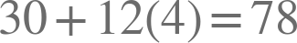 and 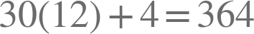. The same three numbers and the same words; what decides is which amount is repeated.

36. SSDD. Every part below is about a square patio of side 15 feet, sealed at 2.20 dollars a square foot with a flat 60 dollars for delivery. Same surface, four different questions: a measurement, an expression, an evaluation, and a size read back out of a total. Only part b has no number for an answer, and only part d runs the structure backwards.
a. What is the area of the patio?
225 square feet
b. Write an expression for the total cost.
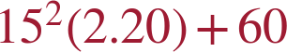
The rate multiplies the area; the flat fee does not.
c. Find the total cost.
555 dollars
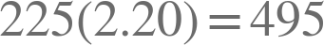, then .
d. A second square patio, at the same rate and the same flat fee, costs 940 dollars. What is its side?
20 feet
, and , whose square root is 20.

37. A square court of side 18 feet is resurfaced at 3.50 dollars a square foot, with a flat 140 dollars for the equipment. Which expression gives the total cost?
○ A. 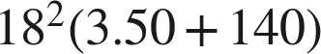
○ B. 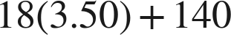
○ C. 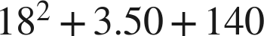
● D. 
D

